Homework 1  
STAT217Q-001  
Write-up

**A: Code:** stress  
Output: Subject...Group.PSSbefore.PSSafter

1 1 A1 Sport 25 13

2 2 A3 Sport 17 15

3 3 A4 Sport 12 13

4 4 A5 Sport 21 22

5 5 A6 Sport 29 25

6 6 A7 Sport 28 24

7 7 A8 Sport 21 19

8 8 B1 Sport 18 19

9 9 B2 Sport 20 24

10 10 B3 Sport 29 21

11 11 B4 Sport 27 22

12 12 B5 Sport 44 33

13 13 B6 Sport 23 8

14 14 B7 Sport 18 12

15 15 B8 Sport 27 30

16 16 A2 Control 0 16

17 17 C1 Control 30 27

18 18 C2 Control 12 31

19 19 C3 Control 29 21

20 20 C4 Control 25 33

21 21 C6 Control 2 9

22 22 C7 Control 6 26

23 23 C8 Control 20 20

24 24 C9 Control 27 28

25 25 C10 Control 14 21

26 26 C11 Control 15 29

**B: Code**: head(stress)  
Output: Subject...Group.PSSbefore.PSSafter

1 1 A1 Sport 25 13

2 2 A3 Sport 17 15

3 3 A4 Sport 12 13

4 4 A5 Sport 21 22

5 5 A6 Sport 29 25

6 6 A7 Sport 28 24

**C: Code**: tail(stress)  
Output: Subject...Group.PSSbefore.PSSafter

21 21 C6 Control 2 9

22 22 C7 Control 6 26

23 23 C8 Control 20 20

24 24 C9 Control 27 28

25 25 C10 Control 14 21

26 26 C11 Control 15 29

**D: Code:** stress$Differences<-stress$PSSafter-stress$PSSbefore  
Output: > stress <- read.csv("~/School/STAT217Q-001/stress.csv", sep="")

> View(stress)

> stress$Differences<-stress$PSSafter-stress$PSSbefore

**E i: Code:** stress$Differences  
Output: [1] -12 -2 1 1 -4 -4 -2 1 4 -8 -5 -11 -15 -6 3 16 -3 19 -8 8

[21] 7 20 0 1 7 14

**E ii: Code:** > mean(stress$Differences)

Output: [1] 0.8461538

**Code:** > sd(stress$Differences)

Output: [1] 9.194313

**E iii: Code:** summary(stress)  
Output: Subject Group PSSbefore PSSafter Differences

A1 : 1 Control:11 Min. : 0.00 Min. : 8.00 Min. :-15.0000

A2 : 1 Sport :15 1st Qu.:15.50 1st Qu.:16.75 1st Qu.: -4.7500

A3 : 1 Median :21.00 Median :21.50 Median : 0.5000

A4 : 1 Mean :20.73 Mean :21.58 Mean : 0.8462

A5 : 1 3rd Qu.:27.00 3rd Qu.:26.75 3rd Qu.: 6.2500

A6 : 1 Max. :44.00 Max. :33.00 Max. : 20.0000

(Other):20

**E iv: Code:** hist(stress$Differences)  
Output: 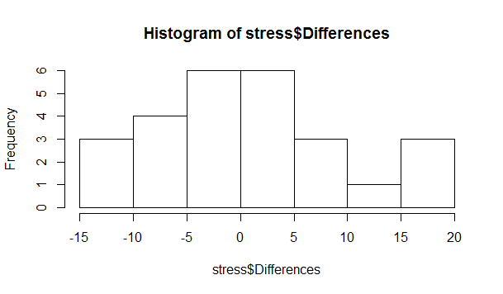

**E v: Code:** boxplot(stress$Differences)  
Output: 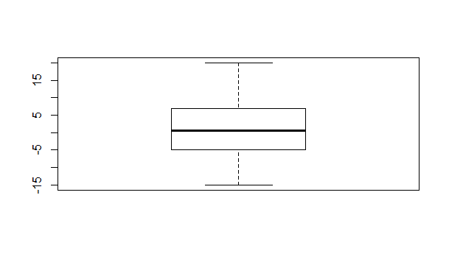

2. Based on the histogram provided by the data and the summary data in part E iii, the average difference in perceived stress levels was near zero for this study. While stress levels do appear to have changed, it does not appear to be drastic across the board. The mean of the differences was 0.8462, with a minimum of -15 and a maximum of 20. There do not appear to be many outliers to skew the data.